c

Viscardi-Gymnasium Oberstufenjahrgang 2024/2026
Fürstenfeldbruck

Seminararbeit im Leitfach
Englisch

Humor, Activism, and the Digital Age:
The Societal Impact of Key & Peele

Verfasser: Karl Andrei Patalinghug
Kursleiter: StDin Eva Gawron
Abgabetermin: 11.11.2025

Note:
Punktzahl:
(einfache Wertung)

(Unterschrift des Kursleiters)

Table of Contents
1. Introduction 3
2. Comedy as a Social Commentary 4
2.1 Sketch Comedy to Address Sociopolitical Issues 5
2.1.1 Key & Peele’s Indirect Activism 5
2.1.2 Open Discourse in a Polarized Society 5
3. Case Study: Deconstructing “Auction Block” 6
3.1 “Auction Block” as a Political Satire 6
3.1.1 Narrative and Character Dynamics 6
3.1.2 Function of Irony and Absurdity 6
3.2 Audience Reception and Sentiment Analysis 7
3.2.1 Methodology and Data Collection 7
3.2.2 Interpretation of Audience Reactions 7
4. Digital Age Activism 8
4.1 The Mechanics of Virality: Applying Berger’s STEPPS Framework 8
4.1.1 Social Currency 8
4.1.2 Triggers 8
4.1.3 Emotion 9
4.1.4 Public 9
4.1.5 Practical Value 10
4.1.6 Stories 10
4.2 From Virality to Discourse 10
4.2.1 Online Discussions and Audience Interpretation 11
4.2.2 Discourse as a Catalyst for Social Learning 12
5. Cultural Impact and Legacy 12
5.1 The Peabody Award 12
5.2 Reaching the Highest Echelon of Power 13
6. Conclusion 14

1. Introduction
In a time marked by deep political divides and pervasive digital media, traditional forms of activism struggle to change public opinion and motivate collective action. As firmly held beliefs become less willing to change through direct persuasion, the digital world has created new ways to influence society and politics. In this new space, political satire has emerged as a surprisingly strong tool that can reach audiences on sensitive and controversial issues.
This paper examines the work of Key & Peele, the comedy duo whose viral sketches propelled them from television stars to important cultural commentators. From 2012 to 2015, Keegan-Michael Key and Jordan Peele's Comedy Central show used humor to tackle some of the most delicate issues in American society, such as race relations, pop culture, and ethnic stereotypes. Their sketches consistently went viral, showing a remarkable ability to connect with a large digital audience. The duo influenced even the highest levels of power, most notably through their celebrated "Anger Translator" sketches and a later partnership with President Barack Obama. This journey from a cable comedy show to the White House highlights their importance and makes them a prime example of how satire serves as a strong means of social influence today.
This paper argues that political satire, as shown by Key & Peele, is a powerful model of activism well-suited for the Digital Age. It acts as an essential form of indirect activism that provides sharp critique and sparks public conversation and social change.
To support this argument, the analysis will unfold in several stages. First, it will define the functions of political satire to establish Key & Peele’s comedy as social commentary. The paper will then closely analyze their viral sketch “Auction Block,” focusing on its narrative and absurdity to critique historical injustice. To measure its real-world impact, this analysis will include a quantitative sentiment analysis of 2,000 audience comments using a specially trained RoBERTa AI model. For this purpose, a sample of 600 comments was manually analyzed and labeled for sentiment, and the model was trained on this dataset using the comment text and its corresponding sentiment. Next, Jonah Berger’s STEPPS framework will explain the sketch's virality and its role in encouraging public dialogue. Finally, the study will reinforce Key & Peele’s cultural significance by examining their mainstream awards, including a Peabody Award and their famous collaboration with President Barack Obama, showing their influence from viral media to the highest levels of power. By breaking down the elements of their success, this research provides important insights into the changing nature of activism in our current digital society.

2. Comedy as a Social Commentary
This chapter establishes that Key & Peele’s comedy functions as a form of social commentary, which is an essential precondition for understanding how their satirical work influences contemporary activism and shapes societal attitudes toward racial injustice.
The primary objectives of activism are to change laws and policies and to shift public opinion. Traditionally, this has been achieved through direct actions such as protests, public demonstrations, and civil disobedience. In contrast, political satire adopts an indirect approach: it uses humor, irony, and exaggeration to expose contradictions and injustices within society. Research has shown that this humorous method evokes reflection and makes serious subjects more digestible to broader audiences. Political satire has even been described as a hybrid genre of political communication capable of engaging, educating, and influencing the masses.
While studies have identified numerous positive effects of satire, they also acknowledge its limitations. Because satire relies on indirectness and ambiguity, messages can be misunderstood, leading to confusion or even be found offensive. Furthermore, research suggests satire primarily reinforces existing attitudes among like-minded viewers rather than converting opponents, seemingly limiting its capacity for direct political transformation. However, these apparent limitations may constitute the source of satire's distinctive power as social commentary. Rather than functioning as straightforward persuasion, satire operates through indirect engagement, creating cognitive space for reflection that direct argumentation cannot achieve. This could be explained through reactance theory, which posits that overt persuasive attempts threaten individuals' sense of autonomy, prompting them to resist the message and potentially strengthen their original position.
Satire circumvents these defensive mechanisms through its reliance on humor, irony, and indirection. By embedding critique within entertainment, satire could lower cognitive defenses and reduce the perception of manipulative intent, allowing audiences to engage with challenging ideas without feeling personally threatened. This indirect approach creates the possibility for reflection and critical consideration that direct political messaging forecloses. In this way, satire demonstrates a unique capacity to penetrate ideological resistance and sustain meaningful social commentary.

2.1 Sketch Comedy to Address Sociopolitical Issues

2.1.1 Key & Peele’s Indirect Activism
The comedy of Key & Peele demonstrates this indirect yet powerful form of activism. Their sketches frequently address issues on African American identity, police brutality, media representation, and systemic inequality. Research by González has shown that their approach involves deconstructing stereotypes and challenging media narratives to stimulate conversation rather than impose censorship.

2.1.2 Open Discourse in a Polarized Society
According to González, open discourse has become increasingly vital in a polarized society deeply divided by identity and political correctness. To fully grasp the impact of Key & Peele’s work on contemporary activism, it is essential to analyze a representative sketch: Auction Block, which has achieved worldwide recognition.

3. Case Study: Deconstructing “Auction Block”

3.1 “Auction Block” as a Political Satire
Released on February 15, 2012, Auction Block is set at an 1848 slave auction in Savannah, Georgia, during the Antebellum Period, before the American Civil War. The sketch has accumulated over 70 million views, a testament to its cultural impact.

3.1.1 Narrative and Character Dynamics
The scene opens with defiant enslaved men being auctioned on stage with three Lots: A, B and C. The men on B and C resist vocally: “Put that whip down and see what happens,” threatening revolt. However, when they aren’t chosen, the remaining slaves express visible relief. The tone shifts when physically smaller, less imposing enslaved men arrive. Suddenly, the two remaining men become desperate to be purchased, even mocking a small slave for his height. As they are repeatedly passed over, they grow jealous stating: “Can a brother get on Lot A?”.
The climax arrives when the white auctioneer abruptly ends the sale, declaring that he refuses to sell “superficial, bigoted slaves” in order to protect his reputation. The remaining men then reverse their stance entirely, pleading for purchase and listing their supposed qualifications— “I can sleep in a bucket,” “I know magic,” “I’m non-violent”—transforming their earlier defiance into desperate compliance.

3.1.2 Function of Irony and Absurdity
Through absurdity and irony, the sketch educates audiences about slavery in a manner that is both humorous and unsettling. By exaggerating how slave auctions treated human beings as merchandise to be evaluated and sold, Key & Peele make the audience confront the system’s moral contradictions without resorting to didacticism. The comedy makes the subject matter approachable for a broad audience, evidenced by its tens of millions of views and the positive online reception, analyzed later in this chapter.
This effectiveness is particularly significant given the lasting historical amnesia regarding slavery’s central role in the Civil War. As one blog post argues, “Americans are increasingly forgetful of the fact that the Civil War was about slavery” which is backed by research showing this amnesia stems from a deliberate, calculated effort in late 19th and early 20th-century textbooks to promote a "Lost Cause" narrative that sacrificed the historical reality of slavery for the sake of national reunification among white Americans.

3.2 Audience Reception and Sentiment Analysis

3.2.1 Methodology and Data Collection
To measure public reception, a trained RoBERTa AI model was employed to analyze audience sentiment in the YouTube comment section of the Auction Block YouTube video. Across a sample of 2,000 comments, the sentiment was overwhelmingly positive, with the RoBERTa model classifying 77.9% of comments as positive, 16.3% as neutral or unrelated, and only 5.9% as negative (see Figure 4 and Figure 2).
Alongside sentiment, audience engagement was tracked to identify periods of peak activity. As shown in Figure 1, which details the monthly comment count, the most notable engagement occurred between November 2022 and March 2023, peaking in January 2023. Given this concentration of activity, this period was selected as a representative sample for the closer examination that follows.

3.2.2 Interpretation of Audience Reactions
A thematic analysis of comments from the peak period (Figure 3) reveals that direct quotes from the sketch were a dominant feature, appearing in approximately 33% of the sampled comments. This frequent quotation demonstrates high engagement and memorability. These findings suggest that viewers not only recall the humor but also identify with the sketch’s underlying themes. Many commenters related the final scene, in which the remaining enslaved men desperately try to “sell” themselves, to their own experiences in job interviews, illustrates how Key & Peele’s satire translates historical injustice into contemporary social critique.
The prevalence of comments comparing the auction to modern job interviews is a powerful illustration of reactance theory in action. By framing the critique within a humorous, historical context, the sketch circumvents viewers' defenses. Instead of rejecting a direct lecture on the dehumanizing nature of modern capitalism, viewers willingly draw the parallel themselves, creating the 'cognitive space for reflection' that direct persuasion often forecloses.
Through Auction Block, Key & Peele exemplify how comedy can serve as a potent form of social commentary. By employing humor, they turn a painful history into a catalyst for reflection and conversation about race, power, and memory. Although satire may not directly change policies, its ability to raise awareness establishes it as a vital tool within modern activism.

4. Digital Age Activism

4.1 The Mechanics of Virality: Applying Berger’s STEPPS Framework
The viral spread of Key & Peele’s “Auction Block” sketch across digital platforms can be analyzed through Jonah Berger’s STEPPS framework for contagious content. Each element of the framework (Social Currency, Triggers, Emotion, Public, Practical Value, and Stories) contributes to the sketch’s viral trajectory.

4.1.1 Social Currency
The sketch acts as a form of intellectual resource to those who share it. That is because understanding its nuanced humor requires a certain degree of cultural and historical literacy. By sharing the sketch, viewers demonstrate perceptiveness and engagement with complex social commentary. In doing so, they signal not only that they “get the joke,” but also that they appreciate its layered critique of systemic oppression and racial dynamics. This is reflected in the comment topics shown in Figure 3, where numerous commenters display a sophisticated understanding of the sketch’s themes.

4.1.2 Triggers
Memorable phrases and recurring inside jokes ensure that the sketch remains top-of-mind long after viewing. As indicated in Figure 3, many commenters report incorporating quotes from the sketch into real-life conversations. Because it engages with enduring issues such as systemic racism, identity politics, and historical amnesia, its relevance is continually revitalized by ongoing social movements and contemporary discourse. The sketch thus benefits from consistent cultural triggers that sustain its visibility over time.
Moreover, the sketch’s relatability further amplifies these triggers. Viewers identify with the desperate pleas of the enslaved characters, contextualizing them as metaphors for modern struggles such as job interviews and competitive labor markets, which is referenced in Figure 3. Comments explicitly connect lines like “My worst quality is that I’m a perfectionist” to real-world experiences of self-promotion and anxiety over limited opportunities. Others relate to the feeling of being excluded, a universal social experience that heightens emotional resonance.

4.1.3 Emotion
Humor and amusement are the sketch’s primary emotional drivers, a fact reflected in the predominance of positive sentiment shown in the sentiment distribution in Figure 2. However, the humor is often intertwined with discomfort or unease. Viewers describe the sketch as “offensively funny.” This emotional complexity intensifies engagement, encouraging reflection as well as laughter.

4.1.4 Public
The sketch’s short format makes it ideally suited for sharing on social media. Its viral success, exceeding 70 million views, demonstrates the power of platforms like YouTube, which facilitate discussion through easily accessible sharing and commenting functions. The visibility of the sketch extends across various platforms: Instagram hosts over 70,000 posts under #keyandpeele, and GIFs from the sketch circulate widely on sites such as 9GAG and Imgur.

4.1.5 Practical Value
While the sketch does not offer direct utilitarian information, it holds intellectual and social practical value. “Auction Block” functions as an accessible entry point into understanding the dehumanizing mechanisms of slavery, transforming a difficult historical topic into an engaging and digestible commentary. The high rate of audience comprehension and appreciation for its underlying critique, as reflected in the comment topics in Figure 3, highlights this pedagogical function.

4.1.6 Stories
At its core, “Auction Block” is a compelling narrative that encapsulates complex social commentary within a memorable storyline. Its clear dramatic arc: from defiance to reluctant compliance, ending in the auctioneer’s unexpected moral reversal, makes it entertaining and thought-provoking. The frequent quotation of lines such as “I will not have my reputation sullied by superficial, bigoted slaves” indicates that audiences internalize and retell elements of the narrative, allowing its messages about racial humiliation, power dynamics, and human desperation to circulate under the guise of humor. Figure 5 illustrates this phenomenon, showing the percentage of usage of keywords from memorable quotes during the most active period of engagement.

4.2 From Virality to Discourse
Although Berger’s STEPPS framework explains the mechanisms behind Auction Block’s virality, this virality only serves as the distribution channel. The more consequential question concerns the dialogues that emerged once the sketch reached millions of viewers. The true activist potential of Key & Peele’s work lies not only in its extensive reach but also in its ability to foster sustained and critical public discourse.

4.2.1 Online Discussions and Audience Interpretation
Discussions surrounding Key & Peele, particularly on platforms such as Reddit, reveal that their sketches serve as catalysts for nuanced debates about satire, race, and representation.

4.2.1.1 Satire vs. Reinforcement of Stereotypes
A central tension concerns whether Key & Peele dismantle racial stereotypes or inadvertently reinforce them. Many viewers interpret the sketches as exposing the absurdity of such stereotypes, using humor to subvert prejudice. However, others voice concerns similar to those expressed by comedians such as Dave Chappelle, warning that certain audiences, particularly white viewers, might misread the satire as validation of racist assumptions.

4.2.1.2 Audience Interpretation and Misinterpretation
Discussion participants emphasize how racial and cultural groups interpret the humor differently. Sketches such as “Auction Block” and “Racist Country Music” are perceived as moving social critiques by some, but as mere entertainment by others. Several commenters highlight the risk of misinterpretation, noting that satire can be co-opted by audiences lacking critical awareness, thereby reproducing the very attitudes it seeks to challenge.

4.2.1.3 Problematic Content and Creative Risk.
Despite overall acclaim, participants also recognize that certain sketches, such as “Rihanna” or “Dungeons & Dragons & Bitches”, contain potentially problematic elements. These conversations, however, often evolve into productive discussions about comedic boundaries and the tension between humor and harm.

4.2.2 Discourse as a Catalyst for Social Learning
The engagement generated by Key & Peele demonstrates how viral content can function as a platform for deliberative public discourse. Because of their widespread accessibility, such sketches attract diverse audiences, fostering spaces where individuals exchange perspectives and critically evaluate differing viewpoints. This dynamic aligns with the principles of deliberative democracy, which emphasizes inclusive, reasoned dialogue among citizens. Such exchanges enhance collective understanding, reduce polarization, and promote empathy by encouraging participants to find common ground on complex social issues. Enhanced accessibility through the internet allows these discussions to transcend geographical and demographic boundaries.
Furthermore, discussion functions not only as a forum for sharing opinions but also as an educational process. Studies have shown that dialogic engagement enhances critical thinking, enhances deeper learning, and strengthens communication skills.
These cognitive and social skills are crucial for grappling with intricate social issues and articulating informed, empathetic responses. In this sense, public discussion inspired by Key & Peele sketches moves audiences from passive consumption to active reflection, enabling them to participate meaningfully in processes of cultural awareness and social change.

5. Cultural Impact and Legacy
The cultural influence of Key & Peele extends far beyond television ratings and viral internet sketches. Its enduring legacy is underscored both by formal recognition from prestigious institutions and through its influence at the uppermost levels of political and cultural power in the United States.
5.1 The Peabody Award
A central indicator of Key & Peele’s impact is its receipt of the Peabody Award, which represents the most definitive form of institutional acknowledgment for excellence in media storytelling. The Peabody Awards honor works that demonstrate outstanding storytelling reflecting contemporary social issues and amplifying emerging voices.
In their acceptance speech, Keegan-Michael Key and Jordan reflected on the evolution of their creative process, stating that they began simply seeking to elicit laughter but ultimately found themselves “uncovering little pieces of truth almost by accident”. They further expressed gratitude to Comedy Central for allowing them to depict the African American experience as diverse and multifaceted rather than monolithic. This moment underscores that the show’s artistic intentions aligned with the very social commentary for which it was celebrated.

5.2 Reaching the Highest Echelon of Power
Perhaps the most compelling evidence of Key & Peele’s cultural and political influence lies in their collaboration with President Barack Obama. This partnership elevated their brand of social satire from the realm of television entertainment to that of political performance. At the 2015 White House Correspondents’ Dinner, Keegan-Michael Key appeared as “Luther,” the fictionalized “anger translator” for President Obama, articulating the frustrations that the president’s calm public demeanor could not openly express.
Obama’s active participation in this routine signifies not only an endorsement of Key & Peele’s comedic style but also an acknowledgment of their sociopolitical insight. The performance became the highlight of the evening, demonstrating that their satire was understood, validated, and appreciated even at the highest levels of American government.
Taken together, the combined weight of the Peabody Award and the collaboration with President Barack Obama, provides undeniable evidence of Key & Peele’s profound cultural impact. They accomplished a unique feat: praised by critics and accepted by the very centers of power their work so sharply satirized. This multifaceted legacy confirms their position as one of the most significant and influential forms of social commentary in modern media. They have demonstrated how comedy can function simultaneously as entertainment, critique, and cultural dialogue.

6. Conclusion
This paper has argued that the political satire of Key & Peele serves as a potent model of indirect activism uniquely suited for the digital age. By dissecting their work, particularly the viral sketch "Auction Block," this analysis has demonstrated how comedy can function as a powerful tool for social commentary, capable of sparking critical public discourse on sensitive issues like racial injustice. The research confirms that in a fragmented and polarized media landscape, satire offers a unique pathway to engage audiences who might otherwise be resistant to direct political persuasion.
Key findings underscore the multifaceted nature of Key & Peele's influence. The detailed analysis of "Auction Block" revealed how the strategic use of irony and absurdity can make deeply unsettling historical topics, such as slavery, accessible to a mass audience, transforming historical amnesia into a subject of contemporary reflection. The quantitative sentiment analysis of audience comments, which showed overwhelmingly positive engagement, and the qualitative finding that viewers related the sketch to modern-day struggles like job interviews, further validate satire's ability to bridge historical injustices with present-day social critiques. Furthermore, the application of Jonah Berger’s STEPPS framework systematically explained the mechanics behind the sketch's immense virality, illustrating how elements like Social Currency, Triggers, and Emotion propelled it into a widespread cultural conversation.
The thesis of this paper—that political satire, as exemplified by Key & Peele, provides sharp critique and sparks social change—is strongly supported by the evidence of their cultural impact. Their work did not remain confined to online platforms but ascended to the highest echelons of cultural and political recognition. The reception of a Peabody Award formally acknowledged their contribution to social commentary, while their celebrated collaboration with President Barack Obama at the White House Correspondents’ Dinner served as an undeniable affirmation of their influence, demonstrating that their satire was not only consumed but also understood and validated by the very power structures it often scrutinized.
The implications of Key & Peele's success are significant for understanding the evolving nature of activism. In an era marked by deep political divisions, their approach demonstrates the power of indirect engagement. By embedding critical commentary within entertainment, their satire effectively lowers the defensive walls that direct argumentation often promotes, creating a space for reflection and dialogue. This suggests that in our current digital society, the most effective forms of activism may not always be the most direct. The ability to foster broad, inclusive, and critical online conversation, as their sketches have done, represents a vital form of social and political action.
For future research, several avenues warrant exploration. A comparative analysis of Key & Peele with other contemporary satirists, such as Sacha Baron Cohen or Ziwe Fumudoh, who have also achieved worldwide recognition, could provide broader insights into the different strategies and impacts of satirical activism. Additionally, a longitudinal study tracking the long-term effects of viral satirical content on public opinion and policy debates could offer more definitive evidence of its capacity to enact social change. Finally, further research could explore the potential pitfalls of satirical activism, particularly the risks of misinterpretation and the reinforcement of stereotypes among certain audience segments, to develop a more nuanced understanding of its limitations and responsibilities.
In conclusion, Key & Peele's legacy lies in their masterful ability to weave entertainment with incisive social critique. They have redefined the boundaries of comedy, demonstrating that humor can be more than just a diversion; it can be a crucial vehicle for truth, a catalyst for conversation, and a vital tool for activism in the 21st century. Their work stands as a testament to the enduring power of satire to challenge, provoke, and ultimately, shape the world we live in.

References
9GAG (2025): Key and Peele tag, in: 9gag.com. URL: https://9gag.com/tag/key-and-peele. (November 7, 2025).
Brugman, Britta C. and Burgers, Christian (2022): How Satirical News Impacts Affective Responses, Learning, and Persuasion: A Three-Level Random-Effects Meta-Analysis, in: Communication Research. URL: https://doi.org/10.1177/00936502211032100. (November 7, 2025).
Center for Teaching and Learning, Columbia University (2024): Fostering Learning Through Discussion, in: ctl.columbia.edu. URL: https://ctl.columbia.edu/resources-and-technology/resources/learning-through-discussion/. (November 7, 2025).
Comedy Central (2012): Key & Peele – Auction Block, in: YouTube. URL: https://www.youtube.com/watch?v=zB7MichlL1k&t=5s. (November 7, 2025).
C-SPAN (2015): CLIP: President Obama’s Anger Translator (C-SPAN), in: YouTube. URL: https://www.youtube.com/watch?v=HkAK9QRe4ds&t=157s. (November 7, 2025).
Eligo Team (2023): Deliberative Democracy: Empowering Communities Through Dialogue, in: Eligo Voting. URL: https://eligovoting.com/deliberative-democracy-empowering-communities/. (November 7, 2025).
González, Mario Fernández (2018): Race, identity and politics in America through Key & Peele: comedy and discourse, in: uvadoc.uva.es. URL: https://uvadoc.uva.es/bitstream/handle/10324/39482/TFG_F_2019_186.pdf?sequence=1. (November 7, 2025).
Heil, Emily (2015): How Barack Obama and His ‘Anger Translator’ Finally Got on Stage Together, in: The Washington Post. URL: https://www.washingtonpost.com/news/reliable-source/wp/2015/04/26/how-barack-obama-and-his-anger-translator-finally-got-on-stage-together/. (November 7, 2025).
Imgur (2025): Key and Peele on Imgur, in: Imgur. URL: https://imgur.com/t/key_and_peele. (November 7, 2025).
Instagram (2025): #keyandpeele hashtag, in: Instagram. URL: https://www.instagram.com/explore/tags/keyandpeele/. (November 7, 2025).
Ishchenko, Olga, Verkhovtsova, Olga, and Lunn, Timothy (2023): The Power of Satire: How to Laugh About Political Issues, in: Lingua Montenegrina. URL: https://doi.org/10.46584/lm.v32i2.1007. (November 7, 2025).
kandp (2012): A discussion on Key & Peele, in: Reddit. URL: https://www.reddit.com/r/SRSDiscussion/comments/14n3qf/a_discussion_on_key_peele/. (November 7, 2025).
Miller, Claire (2021): Rewriting History: How Civil War Textbooks Redefined Our Past, in: Georgia State University Research Magazine. URL: https://news.gsu.edu/research-magazine/rewriting-history-civil-war-textbooks. (November 7, 2025).
Nelson, Megan Kate (2016): Key and Peele’s Reenactment, in: Journal of the Civil War Era blog. URL: https://www.journalofthecivilwarera.org/2016/02/key-and-peele-reenactment/. (November 7, 2025).
Peabody Awards (2014): Key & Peele – 2013 Peabody Awards Acceptance Speech, in: YouTube. URL: https://www.youtube.com/watch?v=rfTGF0mg89o. (November 7, 2025).
Quick, Brian L., Shen, Lijiang, and Dillard, James Price (2013): Reactance Theory and Persuasion, in: The Persuasion Handbook: Developments in Theory and Practice. (November 7, 2025).
The Consumer Researcher (2013): Jonah Berger: The Secrets Behind Why Things Catch On, in: consumerresearcher.com. URL: https://consumerresearcher.com/jonah-berger-contagious. (November 7, 2025).
The Peabody Awards (2025): Peabody Awards, in: peabodyawards.com. URL: https://peabodyawards.com/. (November 7, 2025).

List of Figures

Figure 1:
Monthly Comment Count (December 2013 - September 2025),
(Creation: by Author)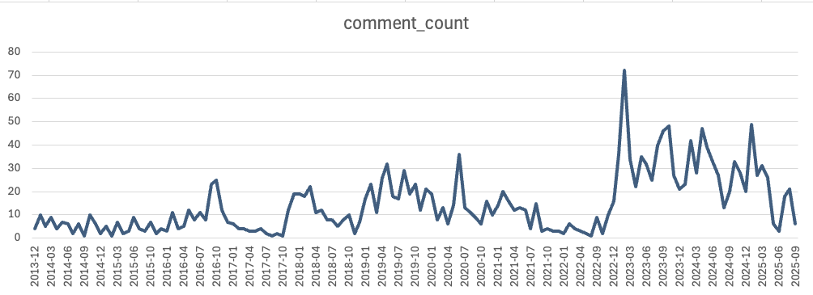

Figure 2:
Distribution of Positive, Negative, and Neutral Comments on "Auction Block," (Creation: by Author)
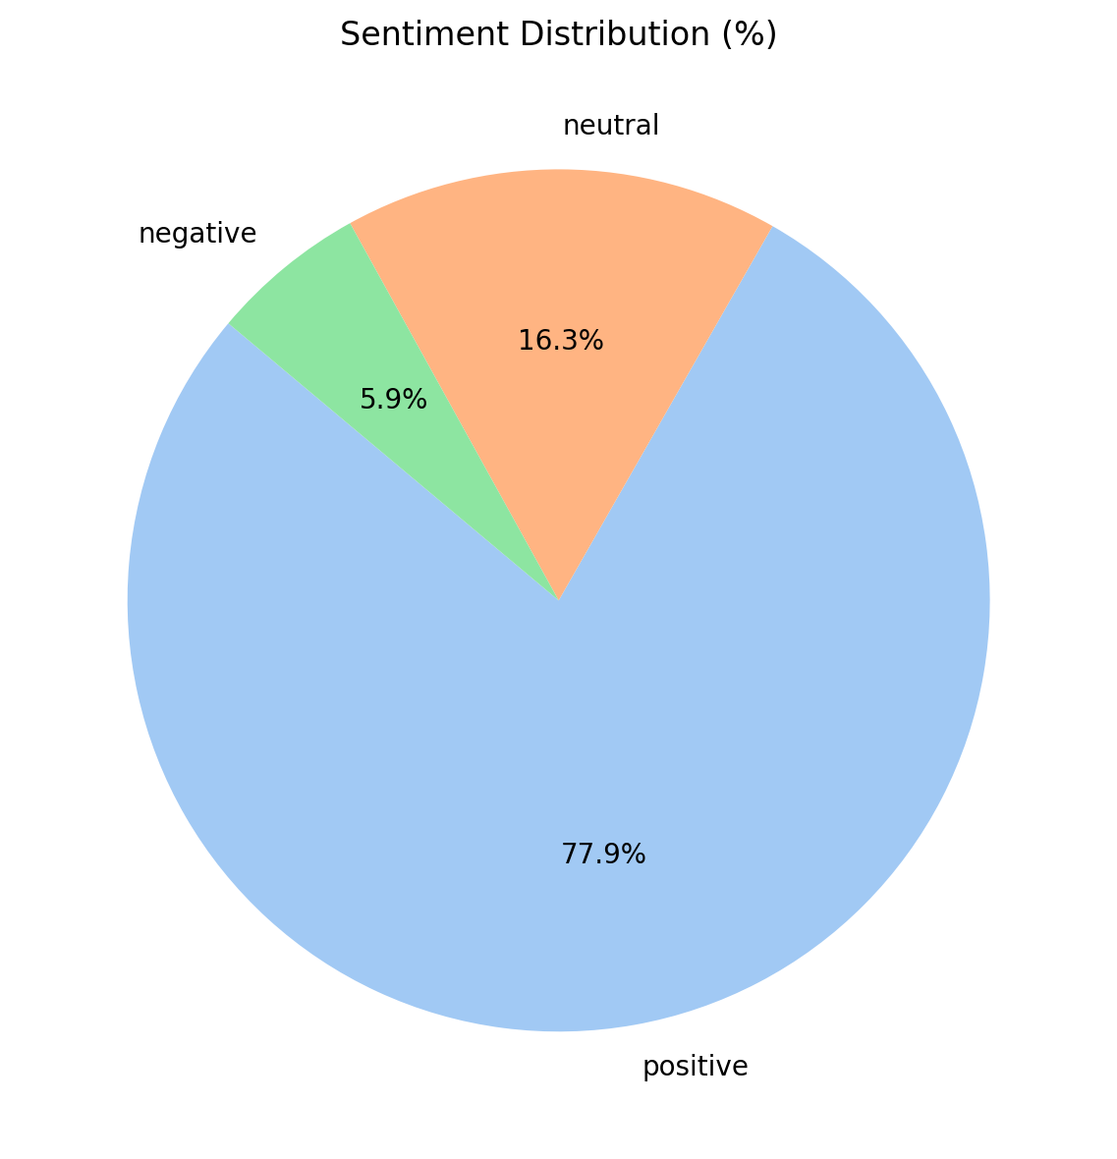

Figure 3:
Comment Topics (November 2022 - March 2023),
(Creation: by Author)
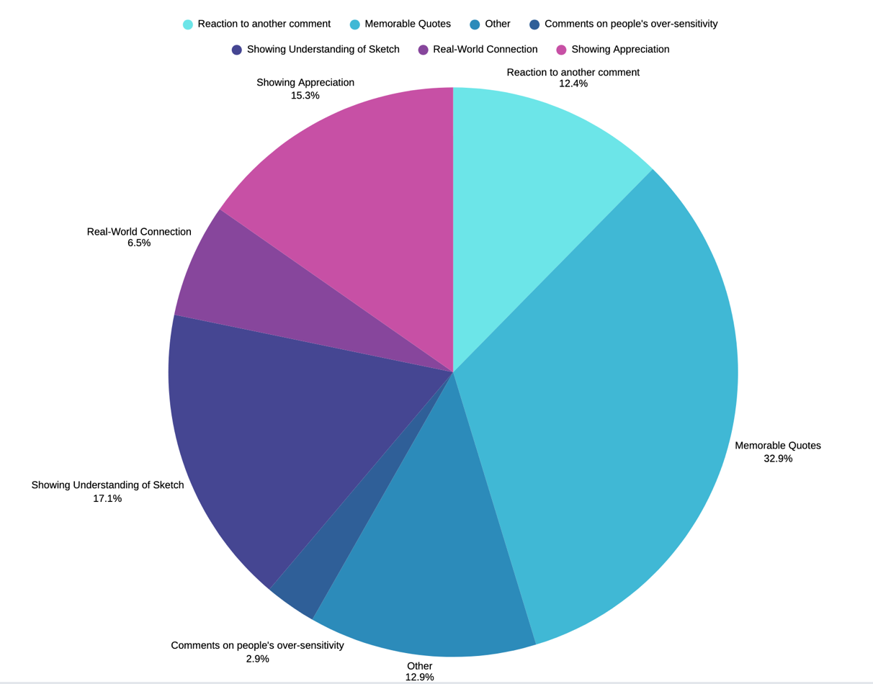

Figure 4:
Comment Sentiment over-time (December 2013 - September 2025),
(Creation: by Author)
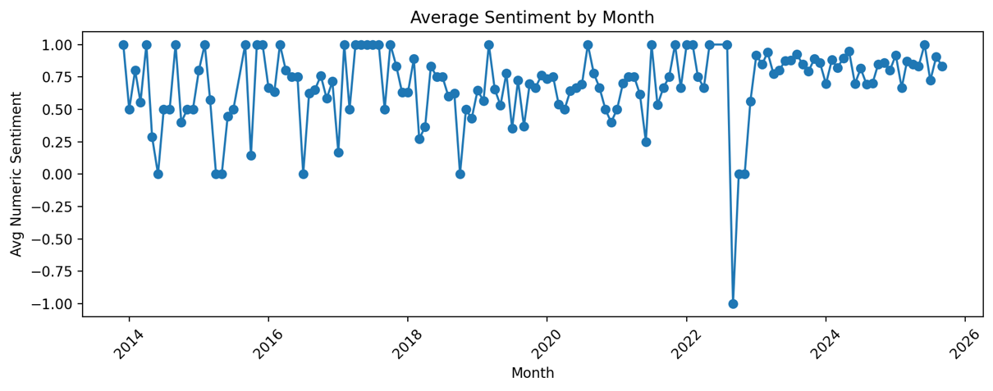

Figure 5:
Keywords of memorable quotes (November 2022 – March 2023),
(Creation: by Author)
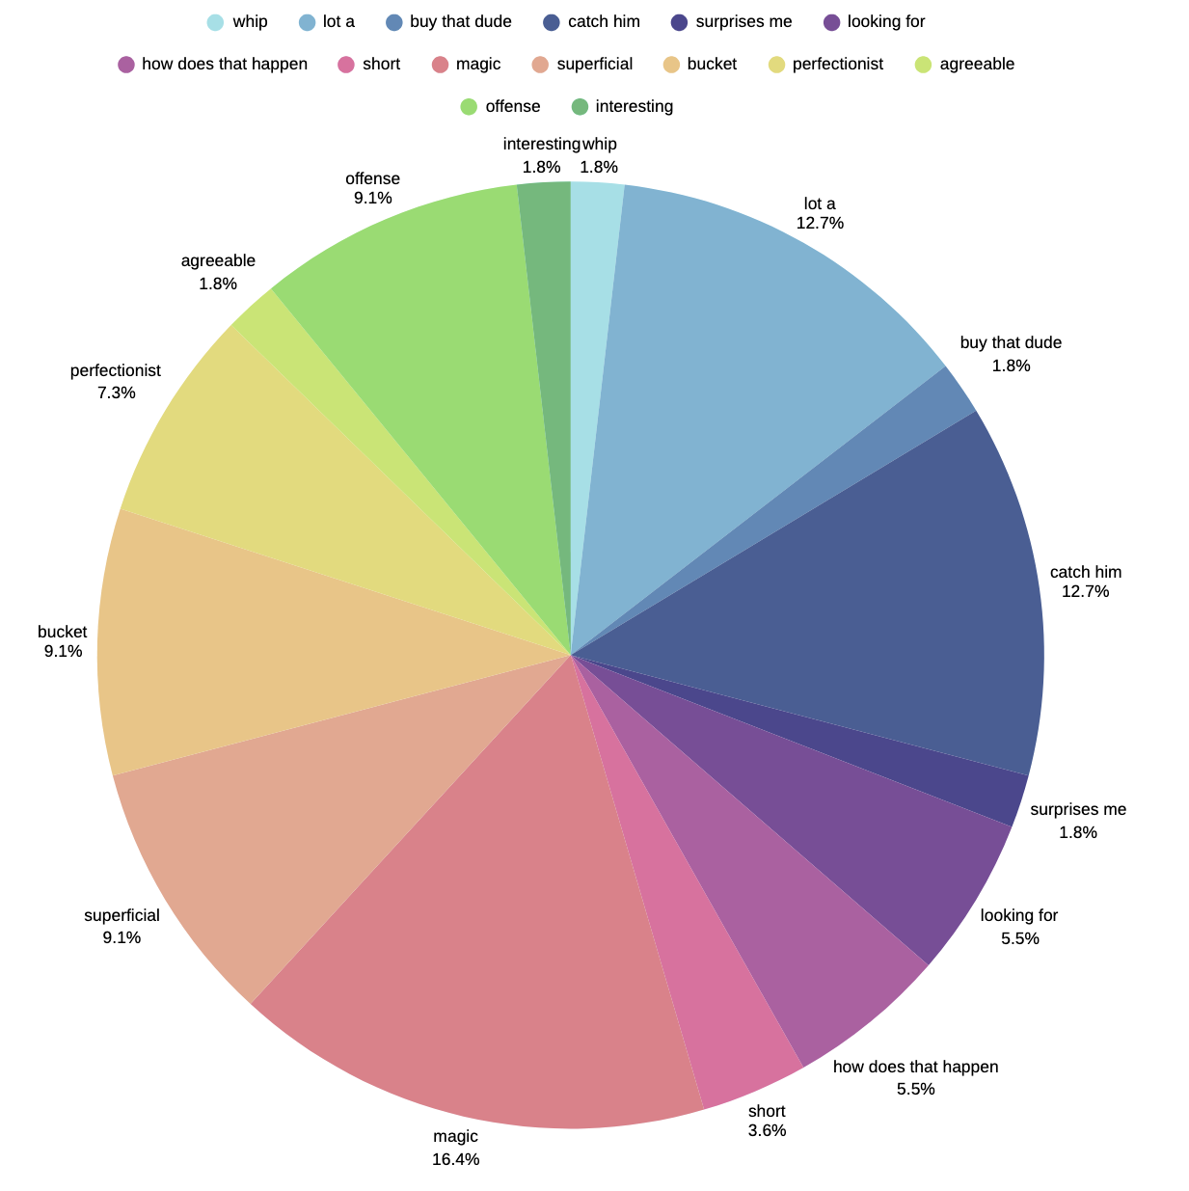

Schlusserklärung

Ich versichere, dass ich die vorgelegte Seminararbeit persönlich und unverfälscht verfasst, sämtliche hierfür zu Hilfe genommene gedruckte sowie digitale Quellen im Literaturverzeichnis angegeben und die aus diesen Quellen stammenden Zitate oder Belegstellen für sinngemäß wiedergegebene Inhalte in meiner Seminararbeit als solche kenntlich gemacht habe. Das Hilfsmittel KI ist nur in dem von mir in der Anlage dokumentierten Umfang eingesetzt worden.

Die Seminararbeit ist in dieser oder einer ähnlichen Form in keinem anderen Kurs des diesjährigen oder eines vorhergehenden Abiturjahrgangs vorgelegt worden.

Mammendorf, 10.11.2025
____________________________ ____________________________
Wohnort, Datum Unterschrift

Olga Ishchenko, Olga Verkhovtsova, and Timothy Lunn, "The Power of Satire: How to Laugh About Political Issues," Lingua Montenegrina 32, no. 2 (2023): 11-12, https://doi.org/10.46584/lm.v32i2.1007.
Britta C. Brugman and Christian Burgers, "How Satirical News Impacts Affective Responses, Learning, and Persuasion: A Three-Level Random-Effects Meta-Analysis," Communication Research 49, no. 7 (2022): 967, https://doi.org/10.1177/00936502211032100.
Brian L. Quick, Lijiang Shen, and James Price Dillard, "Reactance Theory and Persuasion," in The Persuasion Handbook: Developments in Theory and Practice, 2nd ed., ed. James Price Dillard and Lijiang Shen (Thousand Oaks, CA: SAGE Publications, 2013), 168.
Mario Fernández González, “Race, identity and politics in America through Key & Peele: comedy and discourse” (Undergraduate Thesis, Universidad de Valladolid, 2018), 29, https://uvadoc.uva.es/bitstream/handle/10324/39482/TFG_F_2019_186.pdf?sequence=1.
Ibid., 17-18
Comedy Central, “Key & Peele – Auction Block”, YouTube video, 3:03, February 15, 2012, https://www.youtube.com/watch?v=zB7MichlL1k&t=5s, 0:15 - 0:17.
Ibid., 0:42 – 0:53.
Ibid., 1:23 – 2:12.
Ibid., 1:44-1:55.
Ibid., 2:18.
Ibid., 2:34 -2:53.
Megan Kate Nelson, "Key and Peele’s Reenactment," Journal of the Civil War Era blog, February 10, 2016, https://www.journalofthecivilwarera.org/2016/02/key-and-peele-reenactment/.
Claire Miller, "Rewriting History: How Civil War Textbooks Redefined Our Past," Georgia State University Research Magazine, July 8 2021, https://news.gsu.edu/research-magazine/rewriting-history-civil-war-textbooks.
Chris G. I., "Jonah Berger: The Secrets Behind Why Things Catch On," The Consumer Researcher, September 24, 2013, https://consumerresearcher.com/jonah-berger-contagious.
Comedy Central, “Key & Peele -”, 2:40.
Instagram, "#keyandpeele hashtag," accessed November 7, 2025, https://www.instagram.com/explore/tags/keyandpeele/.
9GAG, "Key and Peele tag," accessed November 7, 2025, https://9gag.com/tag/key-and-peele.
Imgur, "Key and Peele on Imgur," accessed November 7, 2025, https://imgur.com/t/key_and_peele.
Comedy Central, “Key & Peele -”, 2:18.
kandp, "A discussion on Key & Peele," Reddit post, December 13, 2012, https://www.reddit.com/r/SRSDiscussion/comments/14n3qf/a_discussion_on_key_peele/.
Ibid.
Ibid.
Eligo Team, "Deliberative Democracy: Empowering Communities Through Dialogue," Eligo Voting, October 24, 2023, https://eligovoting.com/deliberative-democracy-empowering-communities/.
Center for Teaching and Learning, Columbia University, "Fostering Learning Through Discussion," last modified April 1, 2024, https://ctl.columbia.edu/resources-and-technology/resources/learning-through-discussion/.
The Peabody Awards, Peabody Awards, accessed November 7, 2025, https://peabodyawards.com/.
Peabody Awards, “Key & Peele – 2013 Peabody Awards Acceptance Speech,” YouTube video, 2:12, December 8, 2014, https://www.youtube.com/watch?v=rfTGF0mg89o, 0:33 – 0:44.
Ibid., 1:28.
C-SPAN, “CLIP: President Obama’s Anger Translator (C-SPAN),” YouTube video, 5:10, April 25, 2015, https://www.youtube.com/watch?v=HkAK9QRe4ds&t=157s.
Emily Heil, "How Barack Obama and His ‘Anger Translator’ Finally Got on Stage Together," The Washington Post, April 26, 2015, https://www.washingtonpost.com/news/reliable-source/wp/2015/04/26/how-barack-obama-and-his-anger-translator-finally-got-on-stage-together/.

